MP Expt 9

Aim: Write a Program of calculator in higher level language

Program: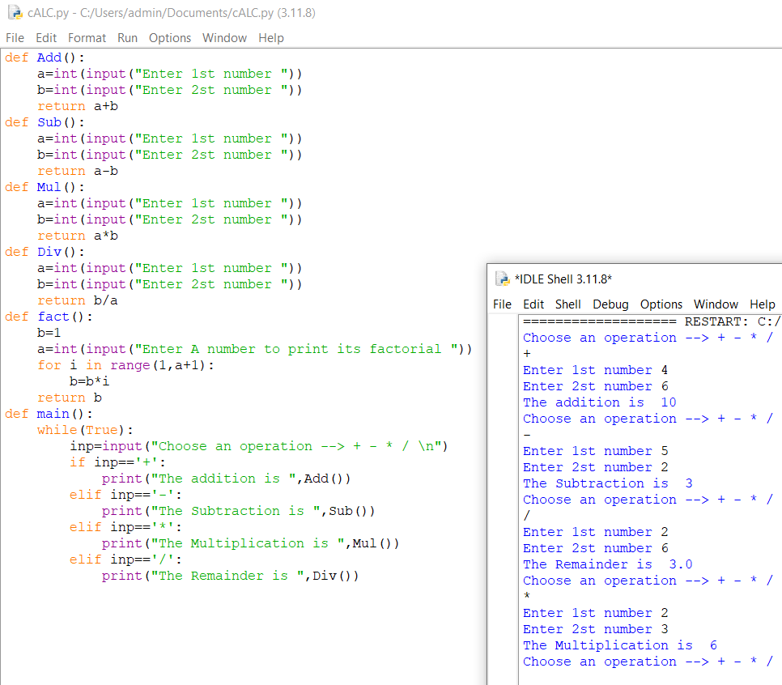

Conclusion: We have successfully Executed the program for calculator.

Name:Abdullah Khan

Roll.no:122A1002 Batch: C1 Batch